TEACHER’S NOTES

Learning Activity 1: Taking Viewing Notes to Describe Effects

Short films are condensed and concise, and good for practising focused and detailed analysis. Note-taking is an essential first step to advance the viewing experience from passive entertainment to active engagement with the film. This is mainly a noticing activity to help students establish good habits and the right frame of mind for analysing a film as a literary text.

Procedures:
- Go through the instructions and ask students to watch the film in class or at home.
- Allow students to view and take notes at their own pace and to pause and replay where necessary.
- Let less advanced students work in pairs or groups (with each student working on one column only), and allow them to pool ideas together to enrich the notes.
- Remind students to describe the audio and visual effects in greater detail.
- Challenge students to guess the director’s intention and explain the desired effects where possible.
- Circulate to observe what features and techniques students can identify and explain and provide language support if necessary.
- Ask students to share their ideas, provide feedback and summarise their points.

Suggested answers:
What happens  - Setting  - Plot  - Characters  - Actions | Audio-visual effects
 | Audio elements:  - Music  - Sound effects | Visual elements  - camera angles, shot lengths, movements  - editing  - special effects
- In the bedroom, a boy hears his phone alarm ring and gets up.  - The title of the film “Snapchat” appears.  - The boy checks his phone, takes pictures and sends text messages while brushing teeth and having breakfast. | - digital alarm and message alert sounds  - rhythmic funky music as background to complement brisk actions  - keypad clicks and camera shutter sounds | - rapid cuts to show actions in a disjointed way, suggesting frequent interruptions and distractions  - close-ups of the phone screen to show text messages and images  - a quick cut to show a goldfish swimming in the fish bowl and the action reversed
- The boy leaves home and takes photos of things he sees on his way to the ferry pier (e.g. the sky, trees, plants, a cat) and shares the images on Snapchat. | - rhythmic light-hearted music to create a sense of spontaneity and show ongoing and repeated activities  - keypad clicks and camera shutter sounds | - frequent cuts to show boy taking many pictures of different things with different angles
- The boy boards a ferry and catches a glimpse of the girl sitting across the aisle.  - He finds the girl attractive and quickly takes a picture of the girl to send to his friends. | - a change from repetitive mechanical music to more lyrical acoustic music to create a sense of tenderness, as the boy sees the girl | - a close-up of the screen to show his comment and view on the girl
- The boy sits with three friends at a table in a café, all looking at their phones and texting each other instead of talking face-to-face.  - The girl comes in and sits at another table with her friend. They start to chat about holidays and movies. | - no music for a while and only keypad clicking sounds as the texting goes on at the table  - light-hearted music as the girl walks in | - a match-cut to bridge the boy texting his friend on the ferry to the boy who is still texting at the café while sitting together with his friends.
- The girl goes to the counter to ask for a glass of water when the boy trips over something from behind and almost falls on the girl.  - The boy’s friends watch from behind and giggle. As the eyes of the boy and girl meet, one of his friends takes a photo of the scene and adds graphics to make up a story out of it. | - a change to more dramatic music to create a magical and comical mood and convey a sense of mischief when the boy bumps into the girl. | - a close-up of the girl at the foreground and then gradual focus on the boy to show their action in tandem  - a close-up of the screen to show the trick and mischief going on with the altered photo  - a close-up of the light to end the scene, with its blurring suggesting impending trouble
- The boy practices asking his dream girl out on a date in front of the mirror at home.  - The picture his friend has taken goes around his circle of friends on Snapchat and is further edited and distorted. | - dramatic music going on as the mischief and misunderstanding escalate  - keypad clicks and message alert sounds | - cross-cuts to show in parallel what happens to the boy at home and the photo in his friends’ hands, creating a steadily escalating conflict/ confusion  - close-up of a lamppost as a transition to bridge to the girl’s side of the story
- The girl is chatting with her friend. Her friend hears a message alert and looks at a picture she received on Snapchat. Both girls are shocked by the picture and wonder how and when it was taken. | - a change of music to convey a sense of shock, surprise and tension as the girls look at the unexpected picture | - two-shots used to show the girls in shock
- The boy sits on a bench, playing with his phone and texting as usual  - A book is dropped near his foot and he bends down to pick it up. Raising his head, he sees his dream girl standing in front of him.  - The girl confronts him with the picture, which he knows nothing about.  - The girl walks away in anger, leaving the boy speechless and just capable of responding with a quick photo of the girl and a text message “If only I could talk” | - a change from soft lyrical music conveying a sense of romance and tenderness (while the boy picks up the book) to comical circus music (as the girl confronts him with the picture)  - comical music to create a sense of absurdity in the end, making the boy a buffoon or an object of ridicule | - shot-reverse shots used to show the confrontation between the boy and the girl  - the boy positioned lower and captured mainly in high-angle shots vs the girl positioned higher, captured mainly in low-angle shots to show the girl’s overbearing presence and power over the boy, as well as the boy’s weakness and inability  - close-ups of the boy’s blank and helpless look as he stutters  - a close-up of the message on the phone screen to show his inability to express himself in speech

Learning Activity 2: Understanding and Appreciating the Film

This activity encourages students to integrate knowledge of the fictional, dramatic and cinematic elements to analyse a film and develop critical responses with textual support.

Teaching Procedures:
- Review the three main aspects of film analysis with students (i.e. the fictional, dramatic and cinematic elements) and remind them to answer the questions with due attention to all three aspects.
- Emphasise the need to consider how dramatic and cinematic elements help plot and character development and thematic conveyance.
- Ask students to answer the questions with textual support (e.g. descriptions of scenes and techniques used) and refer to their viewing notes where necessary.

Suggested Answers:

Plot | - In 100 words, summarise what happens in the film.  A boy is addicted to the social media and constantly sending text messages and photos through Snapchat. However, he lacks the courage and communication skills to talk to his dream girl, whom he meets on a ferry. His friends play a trick on him with a photo secretly taken of them in a cafe. They edit the photo to cook up a romantic story between them. The girl is angry when she sees the picture on her friend’s phone. When she questions the boy, he is lost for words. All he can do is take a picture of the girl as she goes.  - What is the main conflict in the story? How is this conflict built up? Is the conflict resolved in the end?  The main conflict is the misunderstanding and communication breakdown between the boy and the girl. While the boy fancies asking the girl out on a date, the girl is angry with the boy over a modified picture taken without her knowledge. There is a complete mismatch in their responses and intentions, as well as feeling towards each other.  To intensify the conflict and complicate the plot, the film has used a series of cross-cuts to show the actions of the boy, his friends and the girl across different spaces around the same time. Viewers get to see how the photo travels around the Snapchat group and becomes increasingly distorted, as well as see the trouble and misunderstanding escalate. This builds up viewers’ anticipation for the final confrontation.  The misunderstanding is not resolved in the end as the boy lacks the language and social skills to express himself clearly to the girl. He has become a social cripple as a result of his absorption in a virtual world and obsession with the social media.  - On what kind of note does the film end? Describe the ending and explain how cinematic techniques enhance the effects.  The ending of the story is sad and poignant to the boy, as all his efforts on rehearsing the lines are wasted and his dream of getting the girl is completely shattered by the modified picture. The close-up of his face shows his helplessness and great disappointment.  To the audience, the film ends in an ironic and sarcastic note. Despite the repeated practice in front of the mirror at home, the boy stutters and is unable to talk clearly in front of the girl. All he can do is take a picture with his smartphone. He has just been made a victim of cyberbullying and the thoughtless photo taking and sharing on the social media is the root of the trouble he is in. However, he resorts to the source of his doom again and retreats to his virtual world for comfort and relief, which is truly ironic.  To enhance the mocking and sarcastic tone, the films ends with a close-up of the phone screen that shows the message “If only I could talk”, which further establishes him as a pathetic social cripple who can only live in his fantasy and the unreal virtual world. The farcical, circus-like music in the end further accentuates his role as a clown and a buffoon.  - How is the story told in the film? What editing style is adopted?  The story is unfolded in a linear and realist manner with events presented in a chronological order. Continuity editing is adopted and cuts and edits mainly serve to create spatial and temporal connection between events. The editing facilitates the smooth narration and transitions between different settings and characters’ perspectives.
Characters | - Who are the main and supporting characters in the film?  Main: the boy and the girl  Supporting: the friends of the boy and the girl  - Describe the relationship between the boy and the girl in the story.  The boy and the girl in the story are strangers to each other and they are “accidentally” connected through a web of friends on Snapchat. There are three scenes featuring both of them in the same space (i.e. the ferry ride, the café and the final confrontation on the bench), but the boy fails to approach the girl and express himself effectively to establish a meaningful relationship with her. In the end, the misunderstanding escalates and the chance of connecting with her is ruined by a modified picture on the social media.  - How does the film establish the boy and the girl as two opposing characters to bring out their clash?  In the film, the boy and the girl are presented as people from two worlds with different values and lifestyles. While the boy delights in taking random pictures of his life and texting friends rather than talking with them, the girl is presented as more sociable and interested in reading books and chatting face-to-face with friends. Her more intellectual and interpersonal qualities provide a stark contrast with his superficiality and social withdrawal.  The film also uses camera angles and editing techniques to bring out their clash and opposition. Instead of using eye-level shots, the boy and the girl’s final confrontation is presented in alternate high and low angle shots in a sequence of shot reverse shots, showing their imbalance of power, clear split and separation.  Music is also used to establish the difference between the boy and the girl and a mismatch in their expectations. Slow, acoustic and lyrical music is usually used when the girl appears to suggest her “angelic” qualities or present the boy’s romanticised or idealised view of her. However faster, repetitive and mechanical music is usually used to show the mundane and superficial nature of the boy. When the two of them finally see and talk to each other, the gentle music suggesting the boy’s tender feelings is soon replaced by harsh and loud music that complements the girl’s angry accusation, highlighting a mismatch in their expectations and feelings for each other.
Point of view | - From whose point of view is the story told?  The story in presented mainly from the third-person point of view, with the audience being positioned as an ideal observer most of the time. The director focuses the viewers’ attention on different parties (e.g. the boy, the girl or the friends) in different parts of the film to show the full development of the story. Viewers are not bound by the knowledge and perspective of a single character and can understand different sides of the story from different parties’ points of view.
Setting | - Where is the story set? Explain the significance of the setting.  The story takes place in different places ranging from the boy’s home, school, café and other outdoor places. The settings suggest the characters may be students in the same college/institution sharing similar social connections and activity places.  In the context of the film, the changing settings serve to show the phone being the only constant in the boy’s life. The boy is obsessed with his phone wherever he goes and the only way he interacts with the surroundings or responds to the environment is through taking pictures with his phone.
Theme | - What is the main idea (i.e. theme) of the film?  - Social media addiction/obsession  - Communication breakdown  - Cyberbullying  - Social isolation (caused by social media addiction)  - What message can you get from the film?  - Overuse of social media hampers true engagement with others.  - Obsession with social media is harmful to social life and relationships.  - Fulfilling relationships can only be built through interaction with people in the real world.  - We may lose touch with the actual world if we indulge in the virtual world.  - The virtual world can be deceiving.  - Select a static image in the film which best conveys the message of the film. Describe the shot.  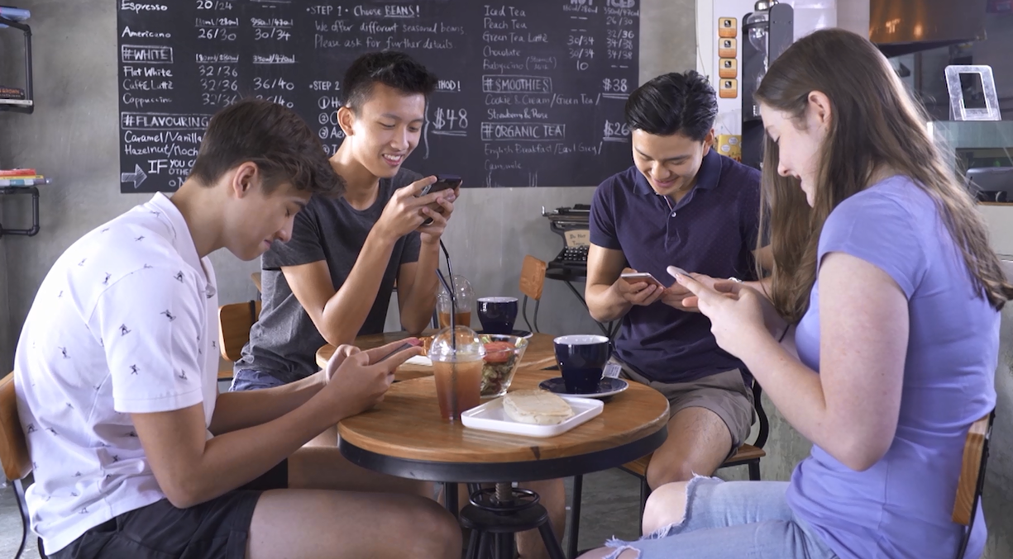  This shot of the boy and his friend sitting around the same table in the café with their eyes glued to their smartphone screens best conveys the theme of smartphone addiction and social isolation. Despite their physical closeness, there is no person to person contact and social interaction in the shot. They are completely absorbed in the virtual world and making little social effort to build a real world relationship. The shot shows social media addiction and overuse can be harmful to social life and relationship.  - How does the use of sound effects help to bring out the theme and message of the film?  Sound effects such as ringtones, keypad clicks of messages being typed, message alert and camera shutter sounds are amplified and repeatedly used in the film, highlighting their pervasiveness in life. The addition of such sound effects not only shows the interruptions and distractions to life smartphones and social media bring, but also helps to depict the characters’ mindless and meaningless living. Apart from sending and responding to messages, many of the characters are shown to have engaged in no other meaningful activities in the film. The frequent use of the sound effects demonstrates how smartphones and social media have become ubiquitous and occupied the characters’ lives.

